University of Nebraska-Lincoln
Glenn Korff School of Music &
the International Quilt Study Center & Museum
i²Choir Fall Semester, 2018 Application & Participant Waiver

Name:______________________________________________________________________

Address: ___________________________________________________________________

City: _________________________________ State: _____ Zip: _____________

Phone: __________________________________ Email: ___________________________________________
Birthdate (month/date): ______ / h______

Year in School (if applicable): _______________________

Name of School (if applicable): ________________________

Preferred Voice Part: Soprano Alto Tenor Bass Not sure

Participant Waiver: I hereby request that you accept this application to the Glenn Korff School of Music’s i²Choir held in UNL’s International Quilt Study Center & Museum during the Fall Semester 2018. In consideration of acceptance of this application, I hereby release the University of Nebraska Lincoln Glenn Korff School of Music, the International Quilt Study Center & Museum, the Board of Regents of the University of Nebraska and all its students and employees from all claims on account of any injuries which may be sustained while attending the i²Choir rehearsals & performances; and I agree to indemnify the Glenn Korff School of Music and all its students and employees, the International Quilt Study Center & Museum and all its employees, the Board of Regents of the University of Nebraska and all its employees for any claim which may hereafter be presented by me as a result of any such injuries.

I also grant permission for the University of Nebraska-Lincoln to use photos, recordings & videos taken at the i²Choir rehearsals & performance for publicity, advertising or other purposes.

Signature of applicant:

Age 19 and under and participants with a legal guardian: I am the parent or guardian of the person named above. I have the legal right to consent to and do consent to the terms and conditions of this APPLICATION & PARTICIPANT WAIVER form.

Parent/Guardian Signature:
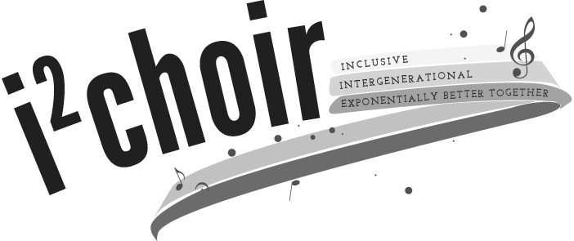
Questions about the i²Choir should be directed to:
Dr. Rhonda Fuelberth
Associate Professor of Music Education
rfuelberth2@unl.edu
(402) 472-3349

http://arts.unl.edu/music/i2choir

